OLD ENVIRONMENT:
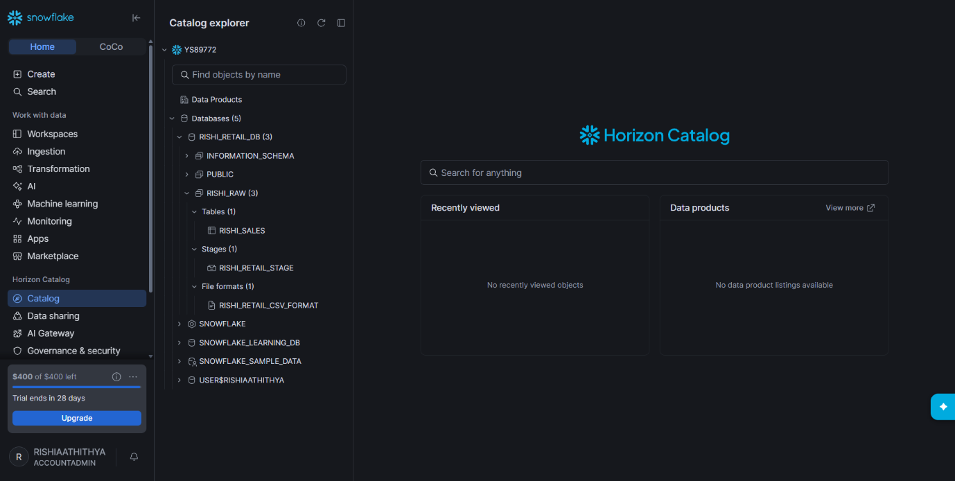

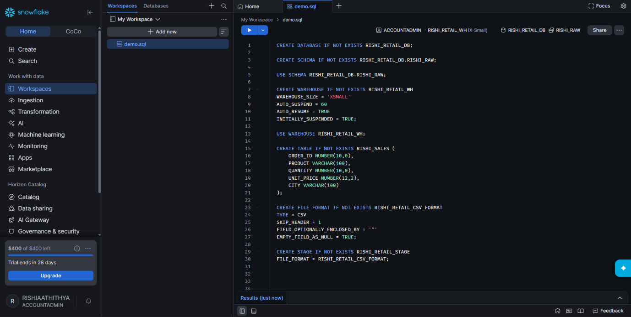
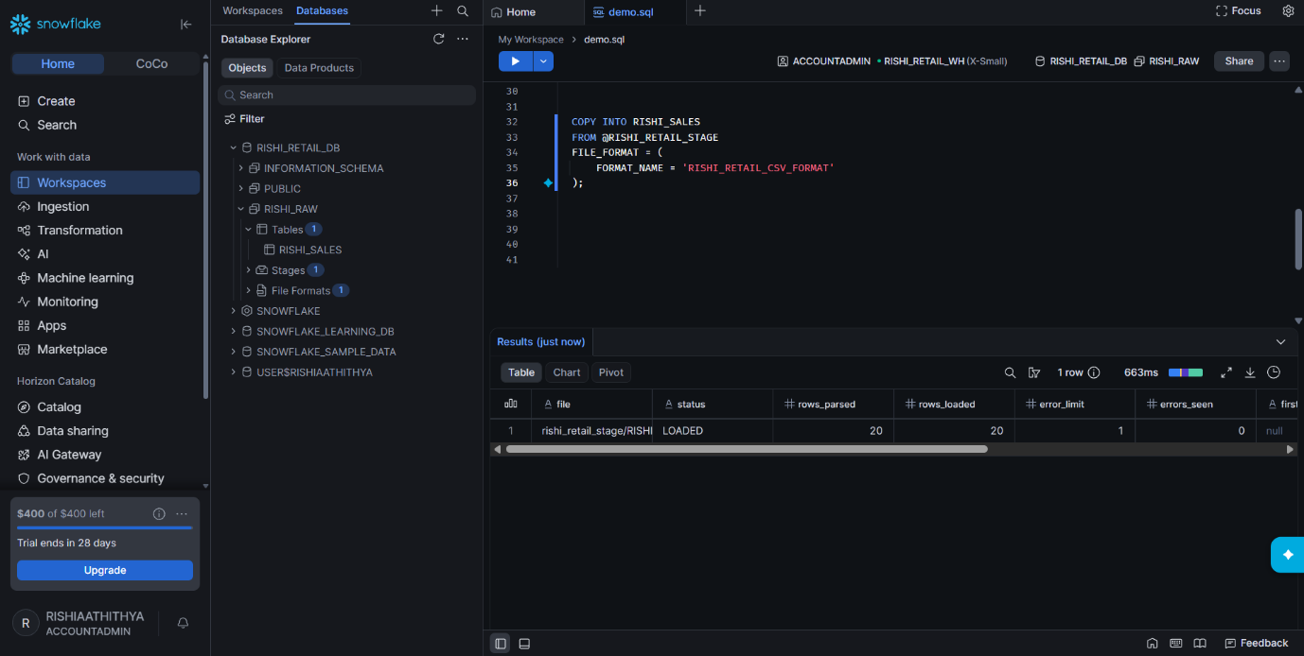

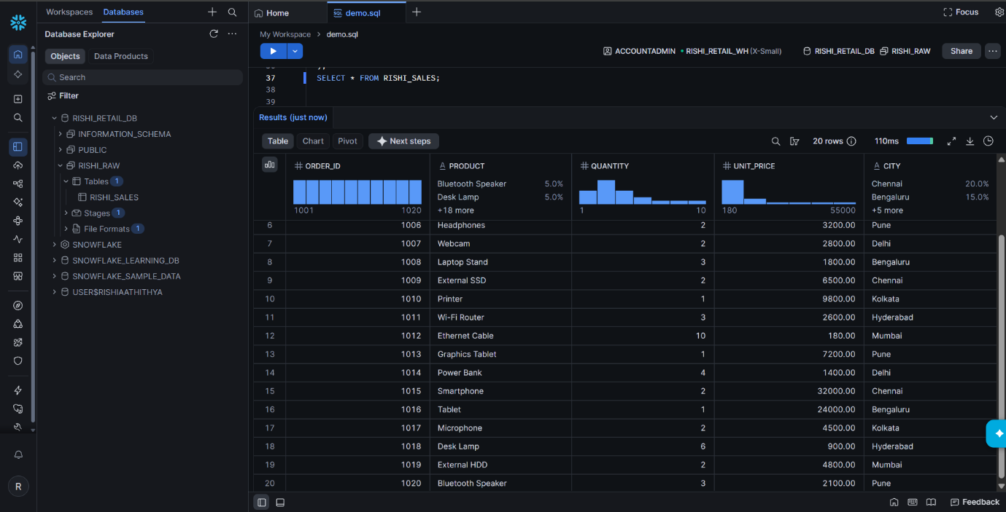

NEW ENVIRONMENT AFTER ADDING TWO TABLES AND TWO FILES:

Display all orders And Customers:
Customer Table
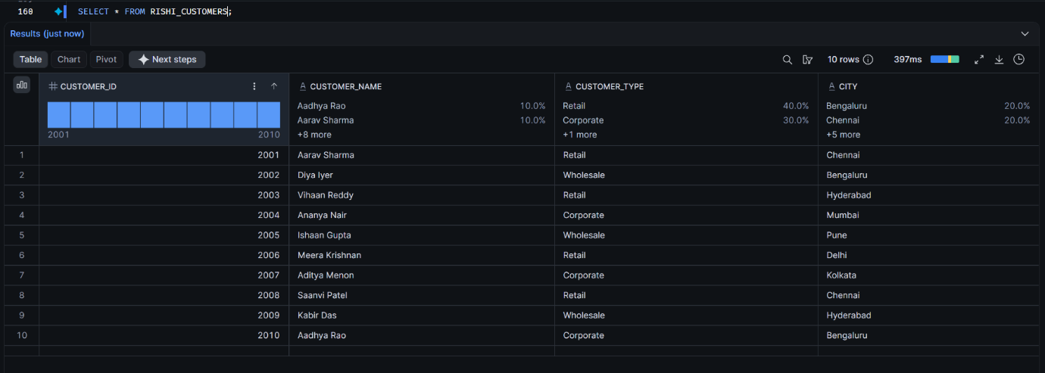
Orders table
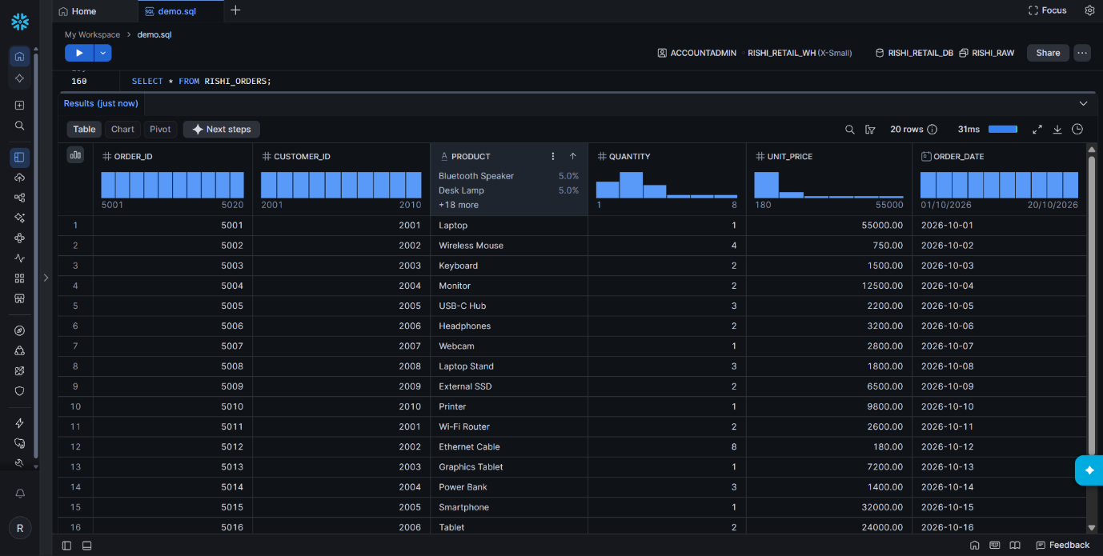

Display orders from a specific location: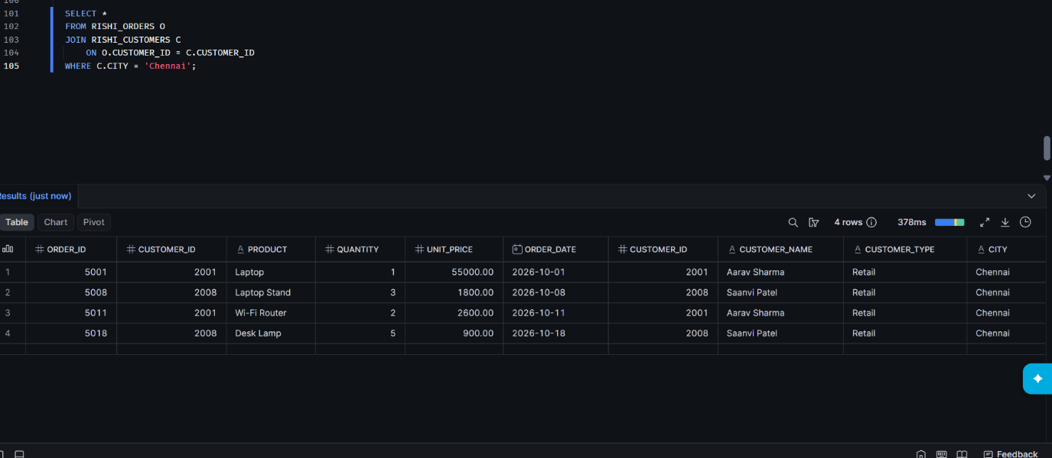
CALCULATE TOTAL SALES OR REVENUE: (AGGREGATION)
SUM(), arithmetic operations :
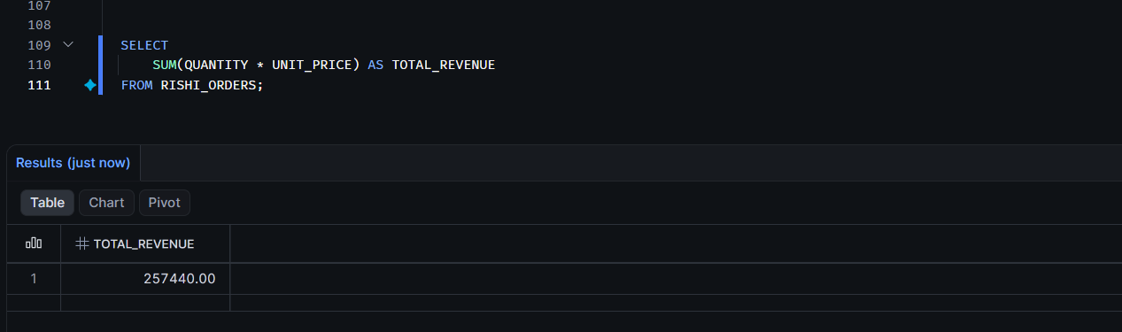
Calculate product-wise sales : (Sum and Group By)
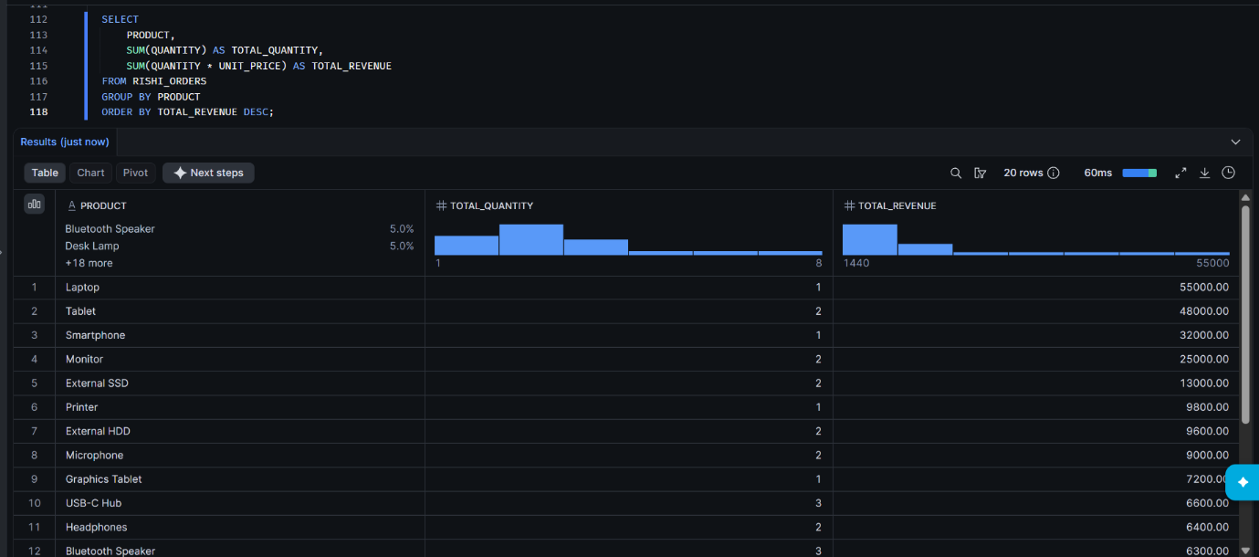
JOIN ORDERS AND CUSTOMERS
INNER JOIN:
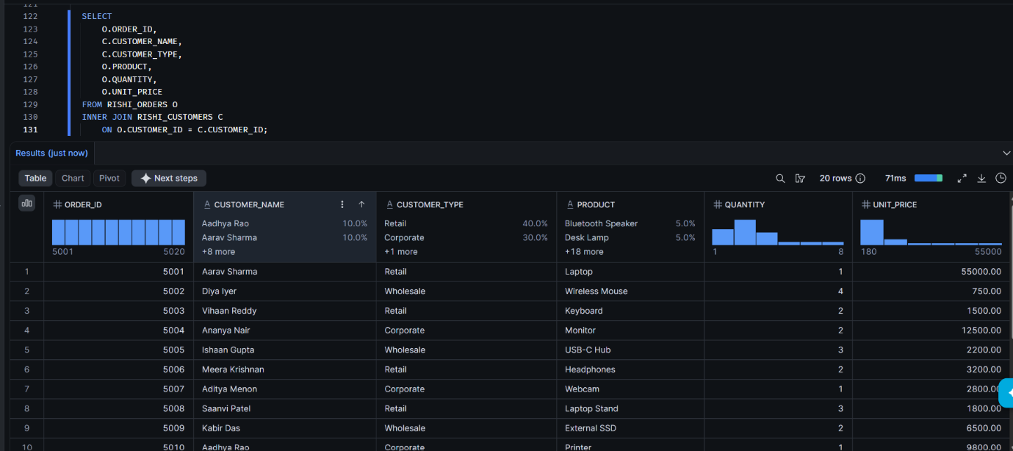
Find total sales using customer type (JOIN, GROUP BY, SUM()):
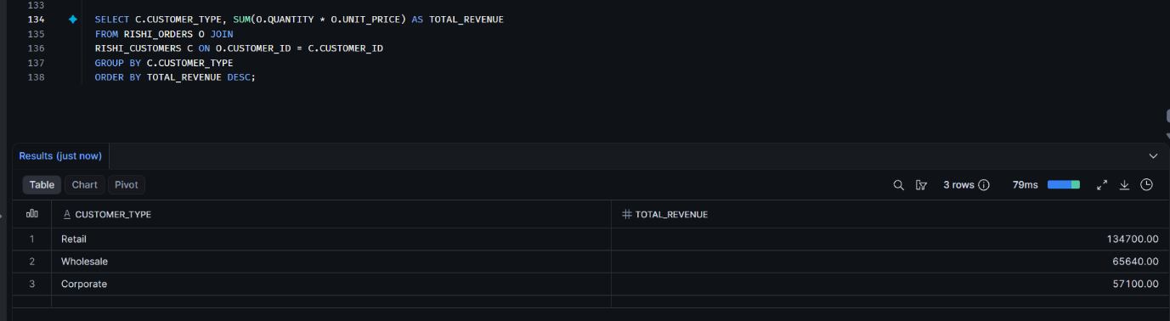
Find customers whose revenue exceeds ₹10,000: (Having ())
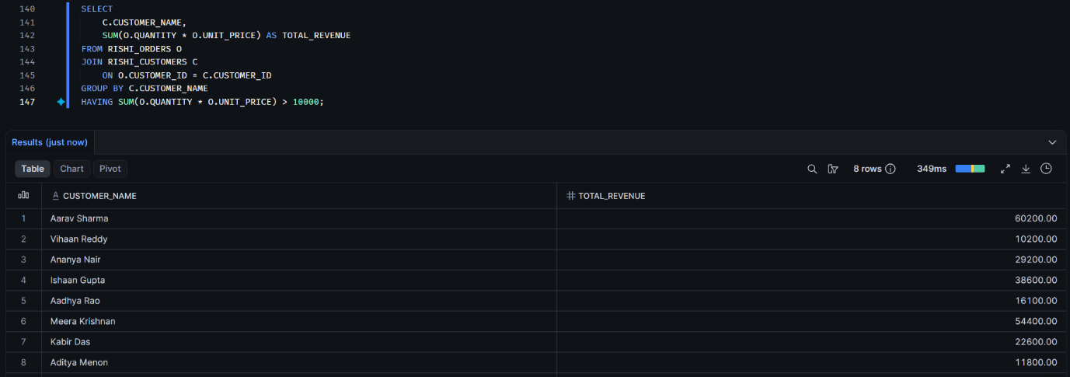

FIND THE TOP 5 EXPENSIVE ORDERS(ORDER BY, LIMIT)
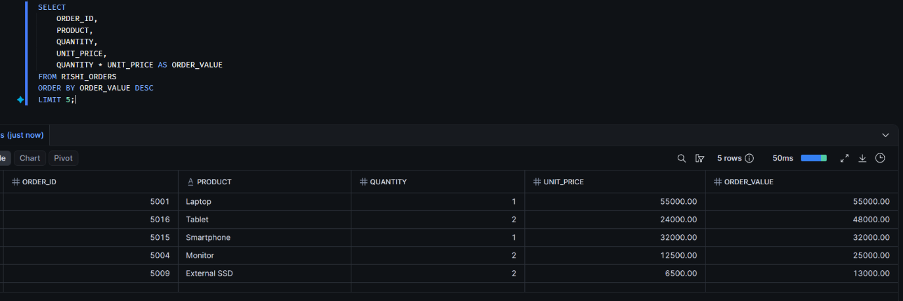

QUERY OPTIMIZATION:
FIRST QUERY:
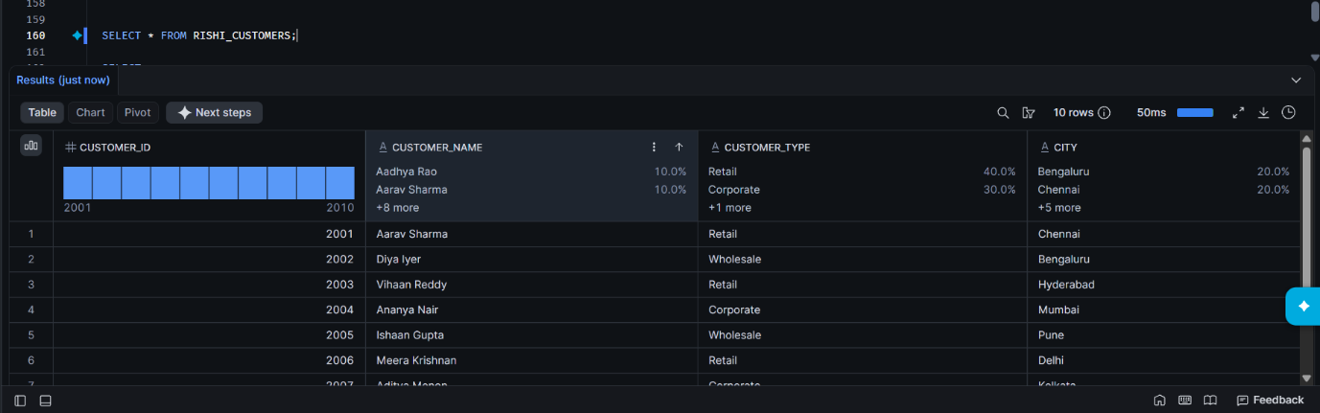

SECOND QUERY: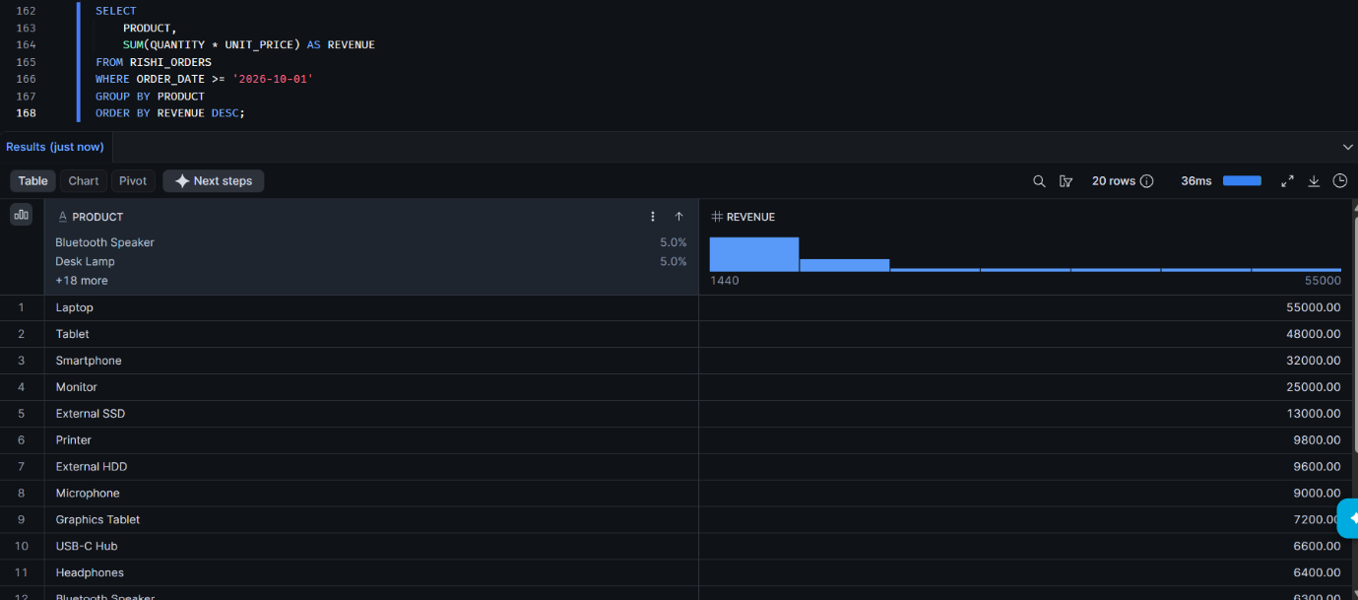
OPTIMIZATION LEVEL AND SIZE:
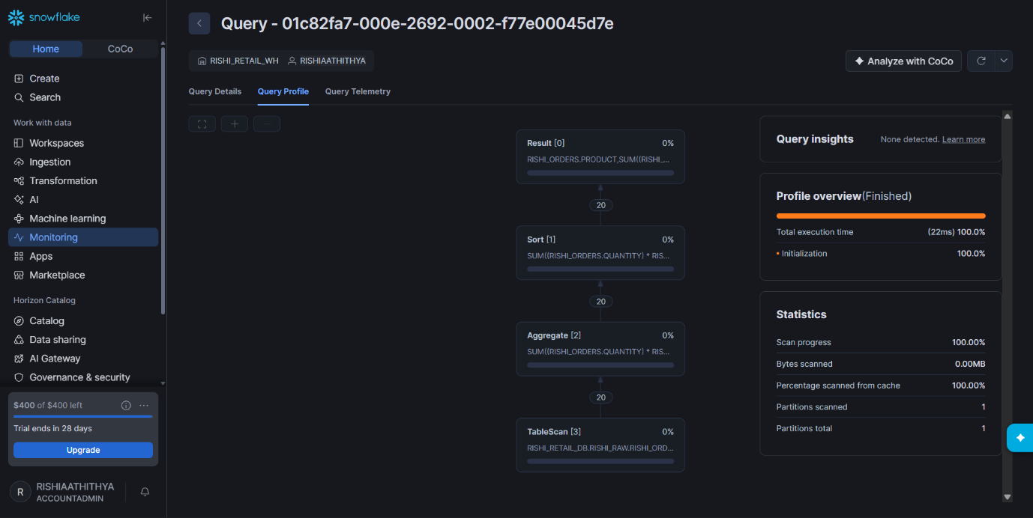

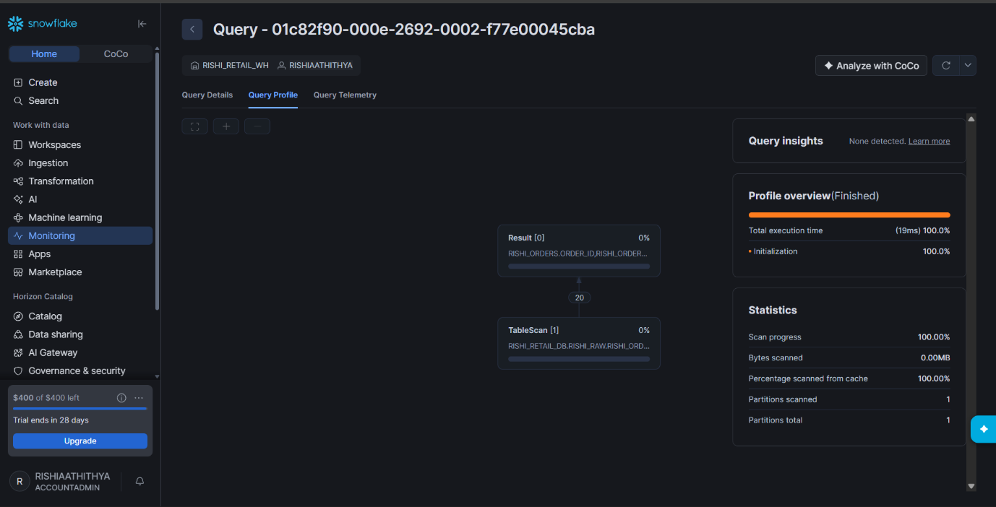

DATA TRANSFORMATION :

TRIM:
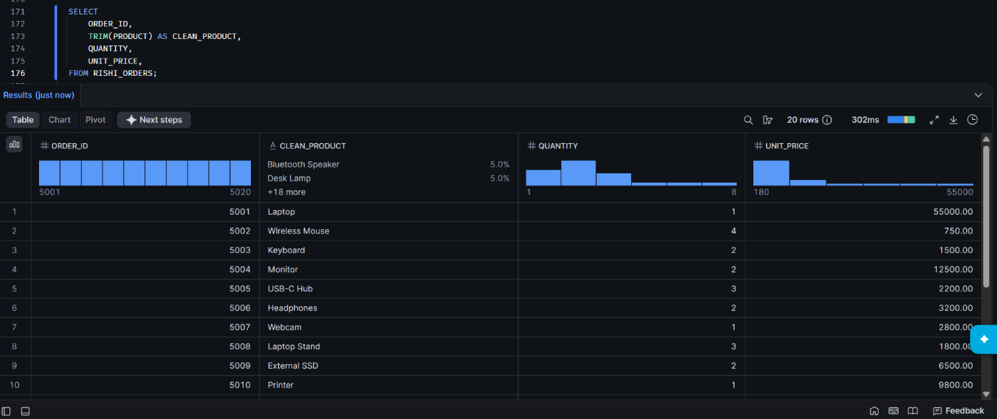

UPPER:
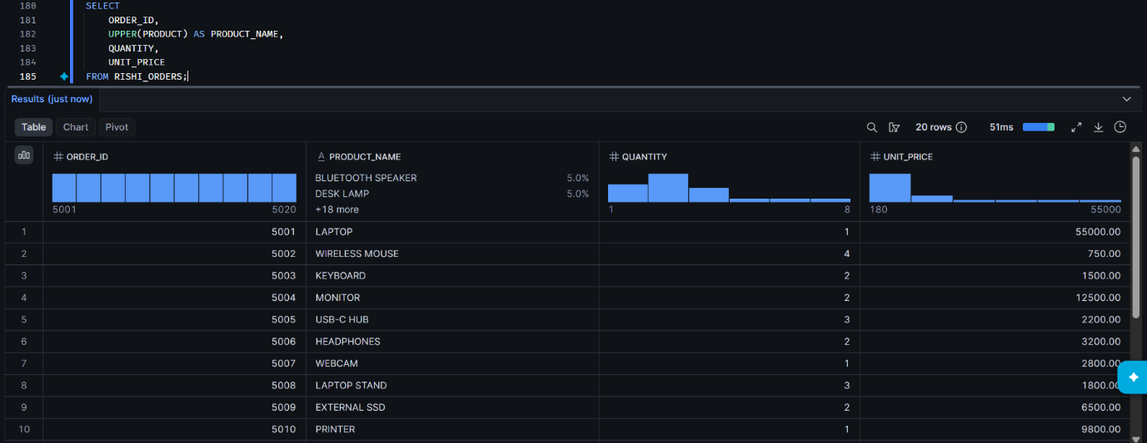
COALESCSE:
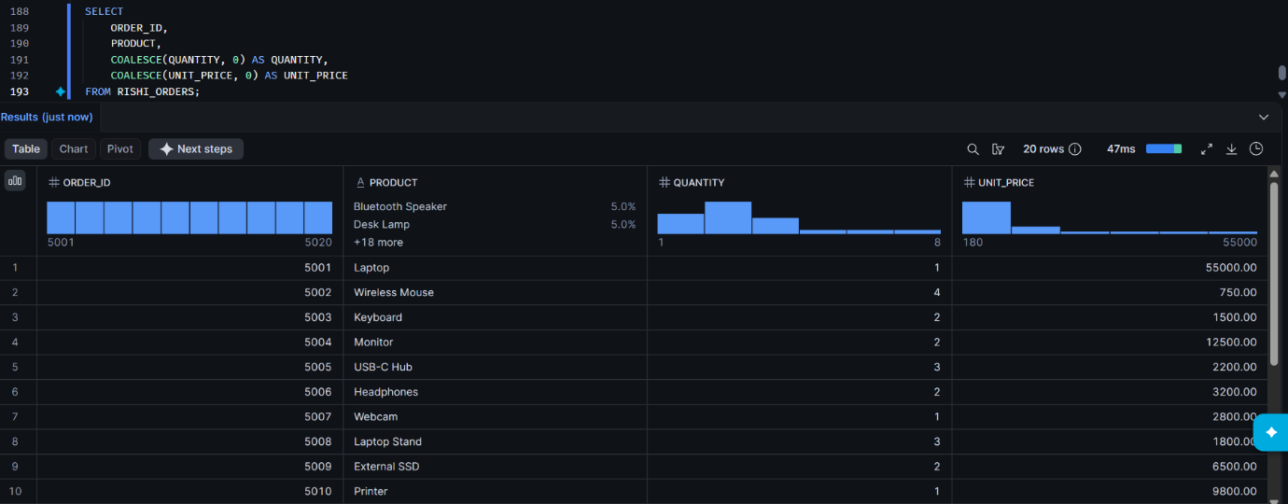

ORDER BY DATE MONTH YEAR:


